CELEBRATE MOM AT

LEO’S  
May Catalog 2025

**Happy Mother’s Day Sunday, May 11th**

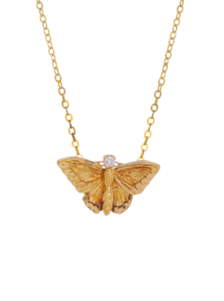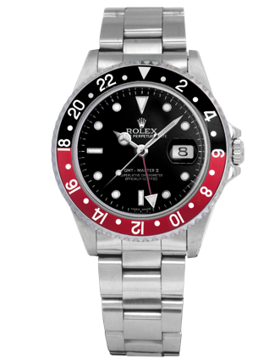

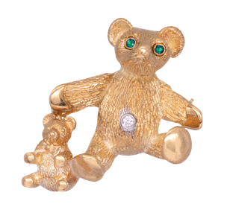

**A close up of a ring

cable bracelet
**

**619.299.1500 www.leohamel.com**

|  |  |  |  |
| --- | --- | --- | --- |
| **gold pendant**  #24052  New 14k yellow gold pendant set with a 2.41 carat  lab-grown diamond &  0.09 carats of lab-grown diamonds.  Retail: $3,375,  **Our Price: $2,950** | **blue diamond gold pendant**  #26031  New 14k white gold pendant set with a 0.69 carat lab-grown blue diamond and 0.18 carats  lab-grown diamond halo.  Retail: $1,475,  **Our Price: $1,295** | white gold earrings  #25303  New 14k white gold earrings set with 2.02 carats of  lab-grown diamonds.  Retail: $950,  **Our Price: $850** | **pink rose earrings**  #26030  New 14k rose gold drop earrings set with  4.75 carats of lab-grown pink & white diamonds.  Retail: $4,795,  **Our Price: $4,095** |

**Lab-Grown Diamond Jewelry**

|  |  |
| --- | --- |
| **yellow gold lab-grown diamond ring**  #26030  New 14k yellow gold Toi et Moi (You and Me)  ring set with a 0.50 carat lab-grown diamond & a 0.50 carat lab-grown sapphire.  Retail: $1,825,  **Our Price: $1,595** | **white gold tennis bracelet**  #25511 New 14k white gold tennis bracelet set with 8.45 carats of lab-grown diamonds.  Retail: $7,950,  **Our Price: $6,750** |

**GOLD IS UP!**

**Get Paid the most for your Valuables!**Gold prices are on the rise again! This could be a good time to cash in and get the   
most money for your gold coins, bullion, or jewelry. And selling gold is easy with   
Leo's Professional Gold Buyers!

**WE BUY!**Jewelry, Diamonds, Watches, Coins,   
Handbags and more!

|  |  |  |  |
| --- | --- | --- | --- |
| San Diego 1851 San Diego Ave 619.299.1500 | La Mesa 8911 La Mesa Blvd 619.644.0000 | Solana Beach 921 Lomas Santa Fe 858.509.5900 | Oceanside 2530 Vista Way #H 760.757.2000 |

**Gifts Under $500**

|  |  |  |
| --- | --- | --- |
| **octopus pendant**  #25878 New 18k yellow gold & sterling silver Denny Wong *Octopus* pendant set with 0.02 carats of diamonds.  **Price: $375** | plumeria earrings  #25875 New sterling silver Denny Wong *Plumeria* earrings set with 0.24 carats  of white sapphires.  **Price: $375** | **solitaire pendant**  #99918211  Vintage 14k white gold solitaire pendant set with a 0.25 carat diamond.  Retail: $1,200, **Our Price: $480** |
| yellow gold hoop earrings  #25377 Vintage 18k yellow gold hoop earrings.  Retail: $425, **Our Price: $375** | pearl earrings  #24040  Vintage 14k yellow gold earrings set  with 7.5mm Akoya pearls.  Retail: $275, **Our Price: $195** | David Yurman Classic Cable bracelet  #20727 Vintage sterling silver David Yurman band set with 0.25 carats of diamonds.  Retail: $775, **Our Price: $395** |
| **starfish bracelet**  #25248 Vintage sterling silver Tiffany & Co.  *Elsa Peretti Starfish* bracelet.  Retail: $600,  **Our Price: $300** | wterling silver earrings with tuequoise  #24976 Vintage sterling silver Zuni earrings inlaid with turquoise.  Retail: $175, **Our Price: $135** | **cable bracelet**  #24043 Vintage sterling silver David Yurman *Classic Cable* bracelet set with 0.07 carats of diamond & black onyx.  Retail: $695, **Our Price: $425** |

LEGEND  
k - karat

**Gifts Under $1500**

|  |  |  |
| --- | --- | --- |
| **open regal band**  #25053 New 18k rose gold Hearts On Fire *Open Regal* band set with 0.07 carats of diamonds.  Retail: $1,000, **Our Price: $750** | huggie hoop earrings  #25712 New 14k yellow gold huggie hoop earrings set with pearls & 0.18 carats of diamonds.  Retail: $1,890, **Our Price: $1,485** | **Hamilton  Jazzmaster Skeleton watch**  #18643 New Hamilton  *Jazzmaster Skeleton* watch  with a purple dial. 36mm.  SS, A, B, C, F.  Retail: $1,295,  **Our Price: $1,100** |
| **butterfly pendant**  #25741 Vintage 18k yellow gold butterfly pendant set with a 0.03 carat diamond on a 14k yellow  gold chain. Retail: $950,  **Our Price: $795** | huggie hoop earrings with rubies  #24584 New 14k white gold huggie hoop earrings set with 0.21 carats of rubies  & diamonds.  Retail: $895, **Our Price: $795** | white gold station necklace  #26769 Vintage 14k white gold  station necklace set with  10.00 carats of  amethyst beads.  Retail: $1,950,  **Our Price: $1,450** |
| white gold pendant cross  #26651  New 18k white gold Hearts On Fire *Signature Cross* pendant set with 0.11 carats of diamonds.  **Price: $1,000** | **Lab-grown pendant**  #24695  New 14k white gold Chatham pendant set with 2.00 carat lab-grown alexandrite & 0.03 carats of lab-grown diamonds.  **Price: $1,175** | mini clutch bag  #26248 Vintage black velvet Gucci *GG Dionysus* mini clutch handbag.  Retail: $1,450, **Our Price: $1,050** |

LEGEND  
k - karat

**Gifts Under $3000**

|  |  |  |
| --- | --- | --- |
| white gold butterfly earrings  white gold butterfly earrings  #19752 New 14k white gold butterfly earrings set with 0.64 carats of diamonds &  0.04 carats of black diamonds.  Retail: $2,250, **Our Price: $1,750** | **A close up of a necklace**  #22686 Vintage 18k white gold tennis necklace set  with 4.45 carats of black diamonds.  Retail: $3,325, **Our Price: $2,650** | **A close up of a necklace**  #23592 Vintage 18k white gold & black rhodium  pendant set with 1.75 carats of diamonds & 0.80 carats of black diamonds.  Retail: $3,995, **Our Price: $2,350** |
| mystical earrings  #23899 New 18k white gold Hearts On Fire *Mystical Star* earrings set with  0.54 carats of diamonds.  Retail: $2,300,  **Our Price: $1,650** | **A white gold ring**  #23077 Vintage 18k white gold ring centered with  a 3.75 black opal flanked by 0.50 carats  of diamonds.  Retail: $3,325, **Our Price: $2,395** | **A gold ring with a green stone and diamonds**  #23638  Vintage 18k yellow gold ring set with a 1.86 carat cabochon jade and a  0.54 carat diamond halo.  Retail: $2,700,  **Our Price: $1,995** |
| **teddy bear brooch**  #24377 Vintage 18k yellow gold Tiffany & Co. T*eddy Bear* brooch/pin set with 0.02 carats of diamonds & emeralds.  Retail: $3,900,  **Our Price: $2,300** | **A silver bracelet with diamonds**  #23467 Vintage 14k white gold tennis bracelet set  with 3.71 carats of diamonds.  Retail: $5,800, **Our Price: $2,900** | **yellow gold bangle bracelet  with emeralds**  #21737 Vintage 14k yellow gold bangle bracelet set with 1.60 carats of diamonds & emeralds.  Retail: $3,400, **Our Price: $2,650** |

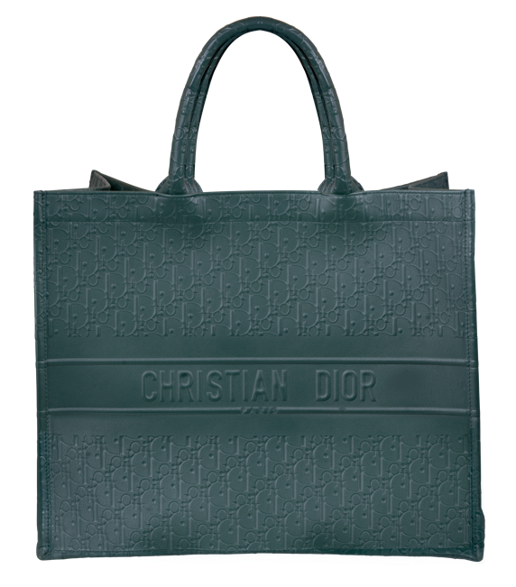

#26245  
Vintage green leather   
Christian Dior   
*Book Tote* with dust cover.

Retail: $3,800, **Our Price: $2,600**

LEGEND  
k - karat

**Engagement Rings**

|  |  |  |
| --- | --- | --- |
| solitaire ring  #26846 New 14k white gold solitaire engagement ring set a. with a  1.55 carat lab-grown diamond.  Retail: $2,195, **Our Price: $1,950** | **yellow gold engagement ring**  #26845 New 14k yellow gold solitaire engagement ring set with a  1.00 carat diamond.  Retail: $2,425, **Our Price: $2,100** | **white gold ring**  #99914993  New 14k white gold ring set with a  2.03 carat diamond surrounded by an  0.18 carat diamond under-halo.  Retail: $28,000, **Our Price: $18,900** |
| **yellow gold lab-grown diamond**  #25058 New 14k yellow gold Chatham ring set with a 2.07 carat lab-grown diamond flanked by 0.37 carats of lab-grown diamonds.  **Price: $2,975** | white gold diamond ring  #13738 New 18k white gold ring centered with a  2.01 lab-grown diamond surrounded by  0.84 carats of diamonds. Retail: $5,925, **Our Price: $4,900** | platinum ring  #26136 Vintage platinum engagement ring centered  with a 2.21 carat diamond surrounded by  1.00 carat of diamonds. Retail: $28,000, **Our Price: $19,995** |
| white gold ring  #99890358 Vintage 14k white gold ring set with an  0.85 carat diamond plus 0.36 carats of  diamonds in the halo and band.  Retail: $3,800,  **Our Price: $1,900** | **A close up of a ring**  #22498 Vintage platinum ring centered with a 2.34 carat diamond plus a  1.06 carat diamond halo & 1.28 carats of diamonds in the band.  Retail: $50,000,  **Our Price: $38,500** | **white gold ring**  #25021 Vintage 14k white gold engagement ring  centered with a 1.18 carat diamond  surrounded by a 0.88 carat diamond halo,  matching wedding band set with 0.50 carats  of diamonds.  Retail: $7,650, **Our Price: $5,900** |

LEGEND  
k - karat

**New & Pre-owned Watches**

|  |  |  |
| --- | --- | --- |
| pwoermaric 80 watch  #24707 New Tissot *Powermatic 80*  watch with a white  dial. 39mm. SS & gold  PVD, A, B, C, F.  **Price: $795** | aviation pilot watch  #24758  New Hamilton  Khaki *Aviation Pilot* watch  with a black dial. 39mm.  SS, A, B, C, L, T.  **Price: $995** | san marcos big gmt watch  #26412 Pre-owned Ulysee Nardin  *San Marcos Big*  *Date GMT*  watch with a blue dial.  40mm. SS, A, C, F.  Retail: $6,100,  Our Price: $2,850 |
| royal oak offshore watch    #26534 Pre-owned Audemars Piguet  *Royal Oak Offshore* *Chronograph*  watch with a black  dial. 40mm. SS, A, C, F, R.  Retail: $35,000,  **Our Price: $21,895** | **rolex datejust watch**  #26229 Pre-owned Rolex  *GMT-Master II*  watch with a red & black  “Coke” bezel. 40mm. SS, A,  C, F, O.  **Price: $12,800** | rolex datejust watch  #26078 Pre-owned Rolex  *Datejust*  watch with slate  diamond dial. 41mm.  SS & 18KW, A, B, C,  F, J.  Retail: $15,500,  **Our Price: $14,700** |

|  |  |
| --- | --- |
| br123 officer watch  #24982 Pre-owned Bell & Ross  *BR123 Officer* watch with  exhibition case back.  41mm. SS, A, C, L, F.  Retail: $2,800,  **Our Price: $1,650** | techograph watch  #26557 Pre-owned Paul Picot  *Technograph* limited  edition #16/100 watch  with exhibition case  back. 44mm. 18KR, A, C, L, T.  Retail: $17,500, **Our Price: $6,900** |

Legend  
18KW – 18k white gold

18KR – 18k rose gold

A – automatic movement

B – box and/or papers

C – sapphire crystal

F – folding clasp

J – Jubilee bracelet

L – leather bracelet

O – Oyster bracelet

PVD – Physical vapor deposition

R – rubber bracelet

SS – stainless steel  
T – tang buckle