CELEBRATE YOUR LIFE AT

LEO’S

**July Catalog 2025**

**ANNUAL HALF-OFF SALE**

**Friday, July 11th 11am-6pm  
Saturday, July 12th 11am-5pm**

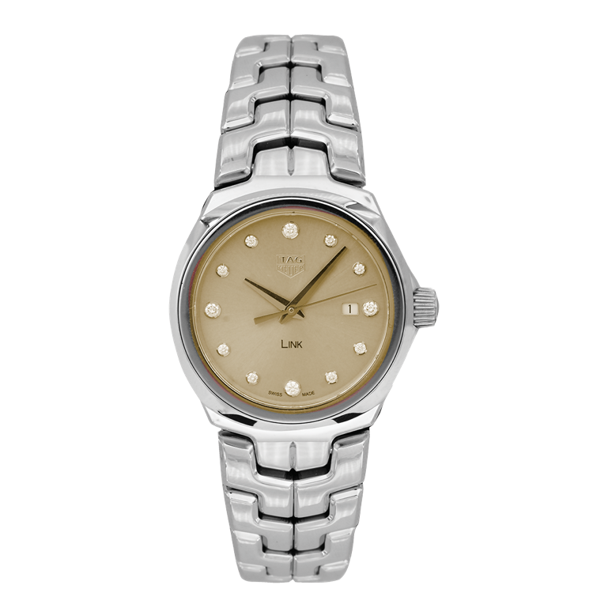**Over $2 million in fine jewelry &   
watches at up to 50% off or more!**

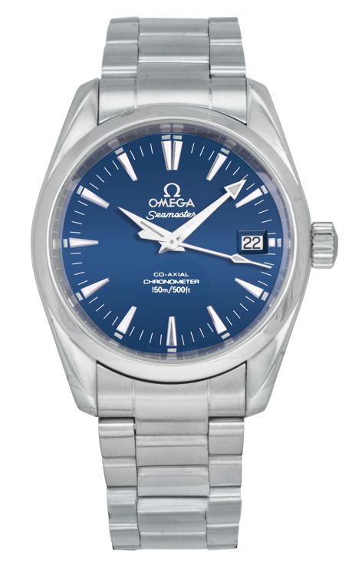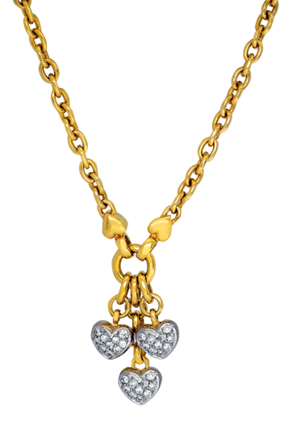

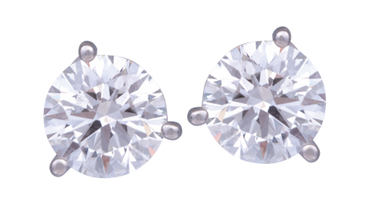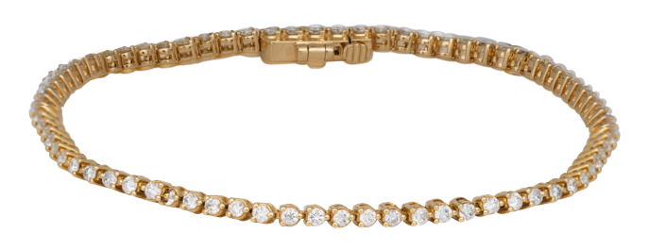

**619.299.1500 www.leohamel.com**

|  |  |  |
| --- | --- | --- |
| A close up of a ring  #18615  New 14k white gold 7-stone band set with 2.10 carats of lab-grown diamonds.  Retail Price: $2,495,  Our Price: $1,497 | **A diamond necklace on a chain**  #17431  New 14k white gold solitaire pendant set with a 0.50 carat lab-grown diamond on an 18" chain.  Retail Price: $795, Our Price: $477 | A pair of diamond earrings  #17436  New 14k white gold earrings set with 5.27 carats of lab-grown diamonds.  Retail Price: $5,575,  Our Price: $3,345 |

**Lab-Grown Diamonds Jewelry**

**40% OFF**

|  |  |
| --- | --- |
| A pair of white spheres  #17426  New 14k white gold halo earrings set with  1.02 carats of lab-grown diamonds.  Retail Price: $975, Our Price: $585 | A gold bracelet with diamonds  #17434  New 14k yellow gold tennis bracelet set with  1.33 carats of diamonds.  Retail Price: $1,825, Our Price: $1,095 |

**GOLD IS UP!**

**Get Paid the most for your Valuables!**Gold prices are on the rise again! This could be a good time to cash in and get the   
most money for your gold coins, bullion, or jewelry. And selling gold is easy with   
Leo's Professional Gold Buyers!

**WE BUY!**Jewelry, Diamonds, Watches, Coins,   
Handbags and more!

|  |  |  |  |
| --- | --- | --- | --- |
| San Diego 1851 San Diego Ave 619.299.1500 | La Mesa 8911 La Mesa Blvd 619.644.0000 | Solana Beach 921 Lomas Santa Fe 858.509.5900 | Oceanside 2530 Vista Way #H 760.757.2000 |

**New Jewelry 40%-50% OFF**

|  |  |  |
| --- | --- | --- |
| A close up of a necklace  99919102  New 14k yellow gold  pendant set with a  1.90 carat aquamarine &  0.06 carats of diamonds.  Retail Price: $1,625,  Our Price: $975 | A necklace with blue stones  #15078  New 14k white gold  Venetti halo necklace set  with 0.41 carats of  sapphires & diamonds.  Retail Price: $1,313,  Our Price: $787.50 | *A diamond necklace on a chain*  #99919089  New Hearts On Fire  *Tessa* circle necklace set  with 1.53 carats of diamonds.  Retail Price: $11,000,  Our Price: $6,600 |
| A pair of gold earrings with diamonds  #15075  New 14k yellow gold Venetti bow earrings set with 0.14 carats of single cut diamonds.  Retail Price: $795,  Our Price: $477 | A gold cross with multicolored stones on a chain  #99912259  New 18k yellow gold  Judy Mayfield cross pendant  set with 1.10 carats of rainbow sapphires & diamonds.  Retail Price: $3,550,  Our Price: $2,130 | A gold bracelet with diamonds  #99913925  New Hearts On Fire *Lorelei Ribbon* flexi bangle bracelet set with  0.62 carats of diamonds.  Retail Price: $4,300,  Our Price: $2,580 |
| A gold bracelet with multicolored stones  #99919103  New 14k yellow gold bracelet set with 7.31 carats of multi-color sapphires & 0.13 carats of diamonds.  Retail Price: $5,995,  Our Price: $3,597 | A silver bracelet with blue stones  #10190  New 14k white gold tennis bracelet set with 1.56 carats of emeralds.  Retail Price: $5,675,  Our Price: $3,405 |

LEGEND  
k - karat

**Engagement & Wedding Bands**

**40%-50% OFF**

|  |  |  |
| --- | --- | --- |
| A diamond ring with a black background  18614  New 14k white gold ring centered with a 1.00 carat lab-grown diamond flanked by 0.92 carats  of diamonds.  Retail Price: $2,795,  Our Price: $1,677 | A close up of a bracelet  #15047  New 14k yellow gold Venetti octagon band set with 0.08 carats of diamonds.  Retail Price: $520,  Our Price: $260 | A close up of a diamond ring  #18876  New 14k white gold halo engagement ring centered with a 1.50 carat lab-grown diamond & 0.66 carats of lab-grown diamonds in the band.  Retail Price: $2,375, Our Price: $1,425 |
| A gold ring with diamonds  #16142  Vintage 14k yellow gold eternity ring set with 3.00 carats of diamonds.  Retail Price: $3,995,  Our Price: $1,997.50 | A close up of a diamond ring  #17679  Vintage 14k white gold solitaire engagement ring set with a  0.91 carat diamond.  Retail Price: $6,600,  Our Price: $3,300 | A close up of a diamond ring  #12710  Vintage platinum engagement ring centered with a 0.91 carat diamond flanked by  0.26 carats of diamonds.  Retail Price: $5,000, Our Price: $2,500 |
| A diamond ring with a black background  #99915420  Vintage 18k white gold engagement ring set with a  1.01 carat diamond & 1.00 carat of diamonds in the band.  Retail Price: $11,000,  Our Price: $5,500 | A diamond ring with a square cut diamond  #22536  Vintage platinum engagement ring centered with a 2.01 carat diamond surrounded by a 0.75 carat  diamond halo.  Retail Price: $22,000,  Our Price: $11,000 | A diamond ring with a black background  17449  Vintage 18k white gold engagement ring centered with a 2.05 carat lab-grown diamond & 0.39 carats of diamonds  in the halo & band.  Retail Price: $5,325, Our Price: $2,662.50 |

LEGEND  
k - karat

**Vintage Jewelry 50% OFF**

|  |  |  |
| --- | --- | --- |
| A gold chain with diamonds and hearts  #21501  Vintage 14k yellow gold  triple heart necklace set  with 0.60 carats  of diamonds.  Retail Price: $9,000,  Our Price: $4,500 | A close up of a snowflake  #15114  Vintage 18k white gold scalloped ring set with 2.70 carats of diamonds.  Retail Price: $4,100,  Our Price: $2,050 | A silver necklace with a square pendant  #99914232  Vintage 18k white  gold enhancer pendant centered  with a 1.04 carat diamond plus a  0.64 carat diamond double halo.  Retail Price: $5,000,  Our Price: $2,500 |
| A gold and silver ring with diamonds  #16603  Vintage 14k yellow & white gold triangle ring set with 0.83 carats  of diamonds.  Retail Price: $2,650,  Our Price: $1,325 | A close up of a ring  #17690  Vintage 14k yellow gold ring set with a 4.00 carat citrine & 1.00 carat of diamonds in the band.  Retail Price: $3,500,  Our Price: $1,750 | A pair of earrings with green stones  #11139  Vintage 18k white gold cluster earrings set with 9.60 carats of emeralds & diamonds.  Retail Price: $7,000,  Our Price: $3,500 |

|  |  |  |
| --- | --- | --- |
| A pair of gold earrings with diamonds  #19968  Vintage 14k yellow gold leaf earrings set with 0.74 carats of diamonds.  Retail Price: $2,650,  Our Price: $1,325 | A pair of gold earrings with blue circles  #13552  Vintage 18k yellow gold drop earrings set with blue glass intaglios.  Retail Price: $1,950,  Our Price: $995 | A silver and blue bracelet  #16223  Vintage platinum tennis bracelet set with 9.40 carats of sapphires  & diamonds.  Retail Price: $12,900,  Our Price: $6,450 |

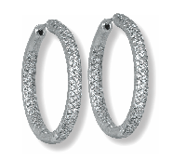Vintage 14k white gold inside-out hoop   
earrings set with   
2.40 carats of diamonds.

Retail Price: $4,400,   
Our Price: $2,200

LEGEND  
k - karat

**Vintage Designer Jewelry & Handbags 50% OFF**

|  |  |  |
| --- | --- | --- |
| A close up of a necklace    #13539  Vintage 18k rose gold Bulgari *Forever* necklace set with 0.16 carats of diamonds.  Retail Price: $3,550,  Our Price: $1,775 | A necklace with a gold panther pendant and pearls  #19757  Vintage 18k yellow gold Cartier *Panthère* necklace strung with  6.5-7mm Akoya pearls &  emerald eyes.  Retail Price: $12,000,  Our Price: $6,000 | A pair of earrings with a yellow circle  #19868  Vintage sterling silver & 18k yellow gold John Hardy *Dot* huggie earrings.  Retail Price: $695, Our Price: $347.50 |
| A close up of a ring  #19164  Vintage platinum Tiffany & Co.  *Jean Schlumberger Lynn* ring set with  0.20 carats of diamonds.  Retail Price: $3,500,  Our Price: $1,750 | A silver infinity necklace with a black background  #19222  Vintage sterling silver Tiffany & Co. *Infinity* necklace.  Retail Price: $300, Our Price: $150 | A black purse with gold chains  #14863  Vintage black leather Yves Saint Laurent *YSL Lou Lou* envelope shoulder handbag.  Retail Price: $3,200,  Our Price: $1,600 |
| A white ribbon with a butterfly shape  #99918321  Vintage sterling silver  Tiffany & Co.  *Bow* brooch.  Retail Price: $500,  Our Price: $250 | A close up of a ring  #99898247  Vintage sterling silver & 18k yellow David Yurman *Buckle* bangle bracelet.  Retail Price: $1,395,  Our Price: $697.50 |

LEGEND  
k - karat

**Pre-owned Luxury Watches**

**50%-60% OFF**

|  |  |  |
| --- | --- | --- |
| A silver watch with black text  #21344  Pre-owned Omega  *Constellation* watch with  a white dial. 22.5mm.  SS, C, F, Q.  Retail Price: $2,500,  Our Price: $1,250 | A close-up of a watch  #16647  Pre-owned TAG Heuer *Link* watch with a diamond dial. 32mm. SS, B, C, F, Q.  Retail Price: $3,100,  Our Price: $1,550 | A silver watch with blue face  # 23382  Pre-owned Omega  *Seamaster Aqua Terra* watch with an exhibition  case back. 36mm.  SS, A, C, F.  Retail Price: $6,300,  Our Price: $2,520 |

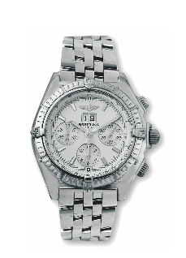

#15986

Pre-owned Breitling   
*Crosswind* watch   
with silver subdials.   
44mm.   
SS, A, C, F.

Retail Price: $6,500, Our Price: $2,600