CELEBRATE YOUR CHRISTMAS AT
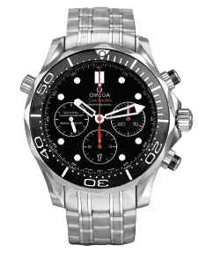
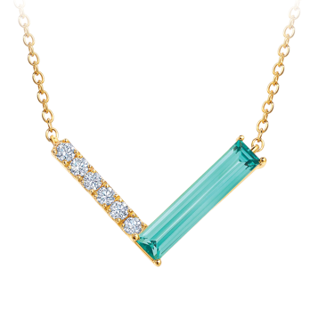
LEO’S
December #1 Catalog 2025
Holiday Hours on the
Back Cover

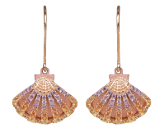

Pg 2
Pg 8

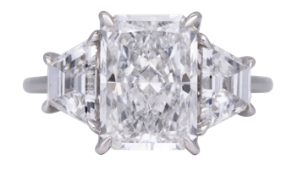
Pg 7
Pg 3
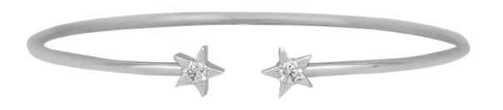
Pg 4

619.299.1500 www.leohamel.com
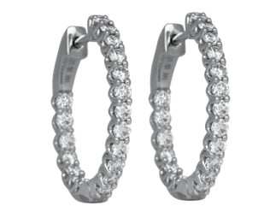  30313  New 14k gold inside out hoop earrings set with 0.99 carats of lab-grown diamonds.  Retail Price: $1,695,  Our Price: $1,495 | 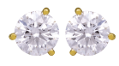  30362  New 14k gold earrings set with 4.04 carats of lab-grown diamonds.  Retail Price: $2,950,  Our Price: $2,650 | 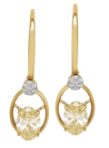  30544  New 14k gold cluster drop earrings set with 2.56 carats of lab-grown fancy yellow oval diamonds & a cluster of  white lab-grown diamonds.  Retail Price: $2,995,  Our Price: $2,695
Chatham Colored Gemstones
& Lab-Grown Diamond Jewelry
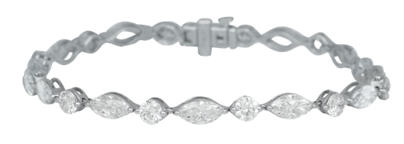  25511  New 14k white gold bracelet set with 8.45 carats of lab-grown diamonds.  Retail Price: $7,950,  Our Price: $6,650 | 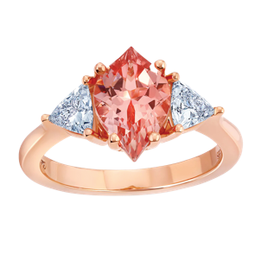  34127  New 14k gold Chatham ring set with a 2.26 carat lab-grown champagne sapphire flanked by 0.57 carats of lab-grown diamonds. Price: $2,725 | 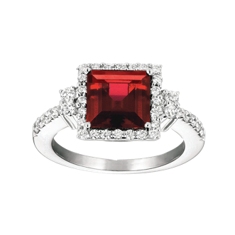  34128  New 14k gold Chatham halo ring set with a 3.45 carat lab-grown ruby & 0.53 carats of lab grown diamonds.  Price: $3,770
34129  New 14k gold Chatham necklace set with a 1.03 carat lab-grown chrysoberyl & 0.15 carats of  lab-grown diamonds.  Price: $1,600 | 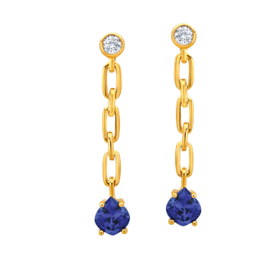  34130  New 14k gold Chatham dangle earrings set with 1.14 carats of  lab-grown sapphires & 0.06 carats of lab-grown diamonds.  Price: $1,495

LEGEND K-Karat = Purity of the gold
Carat = Weight (not size) of the diamond

Engagement Rings & Wedding Bands
Lab-Grown  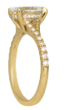  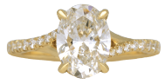  33244  New 14k gold under-halo engagement ring set with a  2.04 carat lab-grown diamond encircled by 0.22 carats of  lab-grown diamonds.  Retail Price: $3,450,  Our Price: $3,250 | Lab-Grown  30562  New 14k gold engagement ring set with a 4.01 carat lab-grown diamond flanked by 1.59 carats of lab-grown diamonds.  Retail Price: $7,495,  Our Price: $6,495 | Lab-Grown  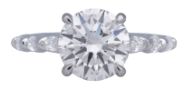  33607  New 14k gold engagement ring set with a 3.02 carat lab-grown diamond &  0.37 carats of lab-grown diamonds in the band.  Retail Price: $4,750, Our Price: $3,995
Lab-Grown  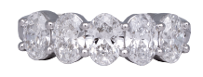  33021  Vintage 14k gold anniversary ring set with 2.00 carats of oval lab-grown diamonds  Retail Price: $2,650,  Our Price: $2,275 | Lab-Grown  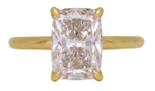  30556  New 14k gold solitaire engagement ring set with a  3.13 carat lab-grown diamond.  Retail Price: $4,195,  Our Price: $3,695 | Earth Mined  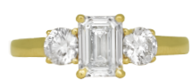  32941  Vintage 18k gold ring set with a 1.00 carat diamond flanked by 0.40 carats of diamonds.  Retail Price: $11,800, Our Price: $8,995
Lab-Grown Diamonds & Earth Mined Diamonds
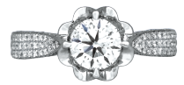  Earth Mined  33680 Vintage 18k gold engagement ring set with a  1.01 carat diamond & 1.00 carat of surrounding diamonds.  Retail Price: $6,900,  Our Price: $5,550 | Earth Mined  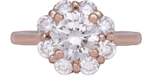  33686  Vintage 14k rose gold ring set with a 1.05 carat diamond & a 0.80 carats diamond halo.  Retail Price: $5,950,  Our Price: $4,750 | Earth Mined  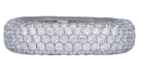  33134  Vintage 18k gold eternity band set with 3.70 carats of diamonds.  Retail Price: $10,000,  Our Price: $7,350

LEGEND
K-Karat = Purity of the gold
Carat = Weight (not size) of the diamond

Vintage Jewelry
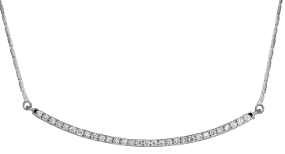  33705  New 14k gold bar pendant set with 0.24 carats of diamonds on a fancy link chain.  Retail Price: $2,095,  Our Price: $1,875 | 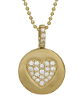  33708  New 14k gold heart pendant set with 0.20 carats of diamonds.  Retail Price: $2,075,  Our Price: $1,875 | 28556  New 18k gold Hearts On Fire Illa Flexi bangle bracelet set with  0.29 carats of diamonds.  Price: $2,900
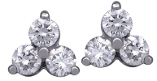  32454  Vintage 14k gold cluster earrings set with 0.40 carats of diamonds.  Retail Price: $650,  Our Price: $500 | 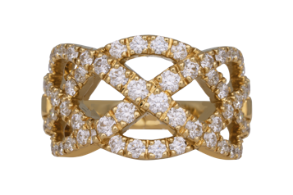  30732  New 18k gold Hearts On Fire brand ring called “Intertwining” set with  1.47 carats of diamonds.  Retail Price: $7,750,  Our Price: $5,650 | 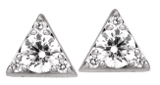  25018  New 18k gold Hearts On Fire Triplicity earrings set with 0.29 carats of diamonds.  Retail Price: $2,250,  Our Price: $1,850
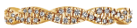

30739
New 18k gold Hearts On Fire brand eternity ring called “Harley Go Boldly” set with 0.32 carats of diamonds.
Retail Price: $3,160,
Our Price: $2,460

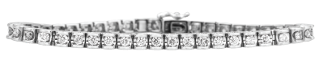

Vintage 14k gold tennis bracelet set with 3.15 carats of diamonds.
Retail Price: $7,800, Our Price: $6,500

LEGEND
K-Karat = Purity of the gold
Carat = Weight (not size) of the diamond

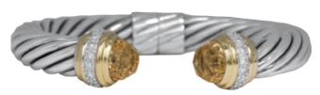  33047 Vintage sterling silver & 18k gold David Yurman Classic Cable cuff bracelet set with 0.48 carats of diamonds & two golden citrines.  Retail Price: $2,300,  Our Price: $1,795 | 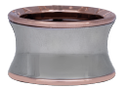  32947  Vintage 18k gold & sterling silver Bvlgari B-Zero ring.  Retail Price: $2,100,  Our Price: $1,495 | 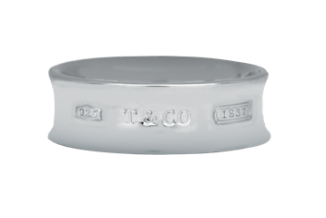  32163  Vintage sterling silver Tiffany & Co. 1837 concave ring.  Retail Price: $450, Our Price: $300
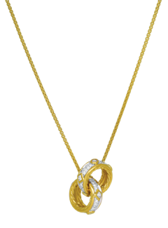  31261  Vintage 18k gold David Yurman Modern Renaissance necklace set with 0.31 carats of diamonds.  Retail Price: $2,950,  Our Price: $2,250 | 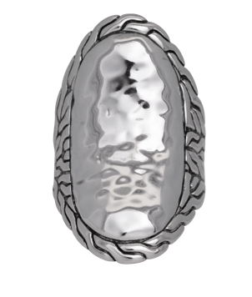  31169  Vintage sterling silver John Hardy Curb ring.  Retail Price: $450,  Our Price: $300 | 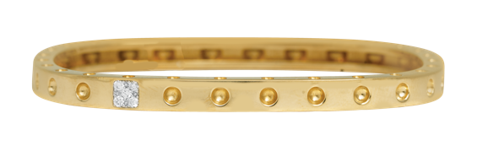  30394  Vintage 18k gold Roberto Coin Pois Moi bangle bracelet set with 0.07 carats of diamonds.  Retail Price: $7,440,  Our Price: $5,495
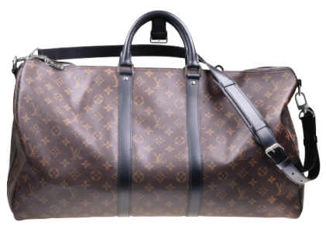
Vintage Designer Jewelry
& Handbags

30988 Vintage monogram Louis Vuitton Macassar s
Keepall Bandouliere 55 duffle with box & dust
cover.
Retail Price: $2,650,
Our Price: $2,250

LEGEND
K-Karat = Purity of the gold
Carat = Weight (not size) of the diamond

Gemstone Jewelry
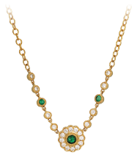  32578 New 14k gold halo flower necklace set with 0.45 carats of emeralds & diamonds.  Retail Price: $3,125,  Our Price: $2,695 | 33586  New 14k gold Denny Wong Shell earrings set with 1.05 carats of pink, yellow, and orange sapphires.  Retail Price: $3,175,  Our Price: $2,775 | 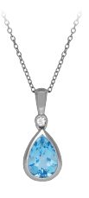  32555  New 14k gold pendant set with  a 1.45 carat blue topaz & a  0.02 carat diamond.  Retail Price: $950,  Our Price: $850
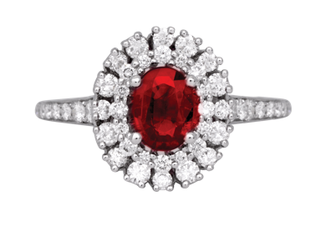  28995  Vintage 18k gold double halo ring set with a 0.72 carat ruby & 0.71 carats of diamonds.  Retail Price: $6,350,  Our Price: $5,350 | 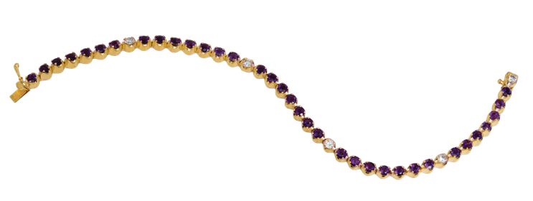  31014  Vintage 14k gold tennis bracelet set with 2.50 carats of amethyst &  0.50 of diamonds.  Retail Price: $3,475,  Our Price: $2,875 | 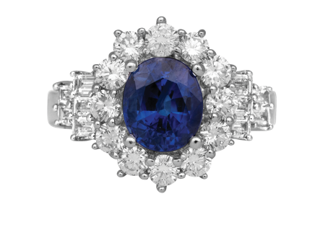  31949  Vintage 18k gold ring set with a  2.34 carat sapphire & a 1.20 carats diamond halo.  Retail Price: $7,400,  Our Price: $6,000
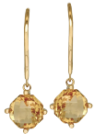  32557  New 14k gold drop earrings set with 2.80 carats of diamonds.  Retail Price: $1,400,  Our Price: $1,250 | 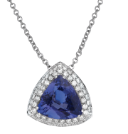  32825  Vintage 14k gold halo pendant set with a 4.90 carat tanzanite surrounded by 0.65 carats of diamonds.  Retail Price: $8,500,  Our Price: $6,750

LEGEND
K-Karat = Purity of the gold
Carat = Weight (not size) of the diamond

New & Pre-owned Watches
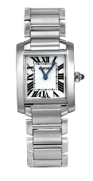  33539  Pre-owned Cartier Tank Francaise with a white dial. 20mm. SS, C, F, Q.  Retail Price: $4,300,  Our Price: $3,695 | 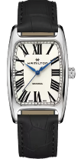  33878  New Hamilton Boulton with a white dial. 34mm. SS, B, C, L, M, T.  Price: $1,075 | 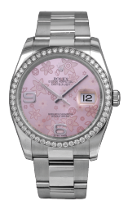  33219  Pre-owned Rolex Datejust with a diamond bezel. 36mm. SS, A, C, F, O.  Retail Price: $17,000,  Our Price: $13,500
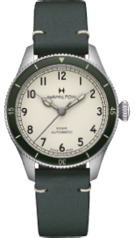  33882  New Hamilton Khaki Aviation Pilot Pioneer with a white dial. 38mm. SS, A, B, C, L, T.  Price: $1,095 | 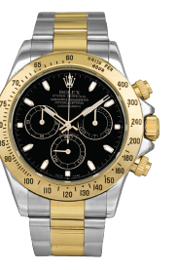  33525  Pre-owned Rolex Daytona Cosmograph with a black dial. 40mm. 18KY & SS, A, C, F, O.  Retail Price: $22,500,  Our Price: $20,950 | 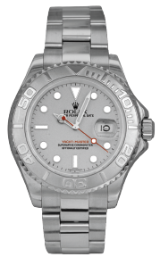  33302  Pre-owned Rolex Yacht-Master with a platinum bezel & a solid platinum dial. 40mm. SS & Pl, A, C, F, O.  Retail Price: $12,500,  Our Price: $10,550
33519  Pre-owned Omega Seamaster 300M Chronograph with a black dial. SS, A, B, C, F.  Retail Price: $7,500,  Our Price: $4,395 |  | LEGEND  18KY – 18k yellow gold  A – automatic movement  B – box and/or papers  C – sapphire crystal  F – folding clasp  L – leather strap  M – mechanical movement  O – Oyster bracelet  Pl – Platinum  Q – quartz movement  SS – stainless steel

Extravagant Deals

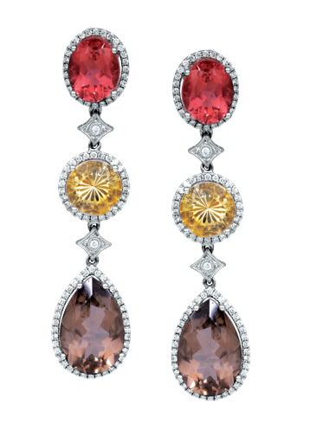  28070  New 18k gold Judy Mayfield drop earrings set with 20.68 carats of tourmaline, citrine, smokey quartz & diamonds.  Retail Price: $14,855,  Our Price: $11,995 | 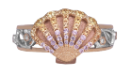  33596  New 14k multi-color gold Denny Wong Hawaiian Sunrise shell ring set with 0.53 carats of multicolor sapphires & 0.03 carats of diamonds.  Retail Price: $3,975,  Our Price: $3,375  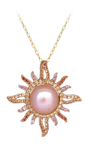  33501  New 14k multi-color gold Denny Wong Sunburst pendant set with  a freshwater pearl & 0.58 carats of multicolor sapphires.  Retail Price: $2,450,  Our Price: $2.150 | 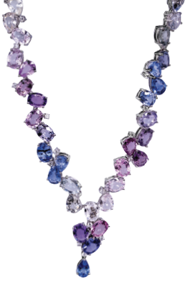  33139  Vintage 18k gold Judy Mayfield convertible bracelet/necklace set with 47.36 carats of multi-color sapphires & diamonds.  Retail Price: $40,000,  Our Price: $24,500

LEGEND
K-Karat =Purity of the gold
Carat = Weight (not size) of the diamond
2025 Holiday Store Hours

SUN | MON | TUES | WED | THURS | FRI | SAT
30  CLOSED | 1  CLOSED | 2  11am-6pm | 3  11am-6pm | 4  11am-6pm | 5  11am-6pm | 6  11am-5pm
7  CLOSED | 8  CLOSED | 9  11am-7pm | 10  11am-7pm | 11  11am-7pm | 12  11am-7pm | 13  11am-5pm
14  12am-5pm | 15  11am-7pm | 16  11am-7pm | 17  11am-7pm | 18  11am-7pm | 19  11am-7pm | 20  11am-5pm
21  12am-5pm | 22  11am-7pm | 23  11am-7pm | 24  11am-3pm | 25  CLOSED | 26  CLOSED | 27  11am-5pm
28  CLOSED | 29  CLOSED | 30  11am-6pm | 31  11am-3pm | 1  CLOSED | 2  11am-6pm | 3  11am-5pm

