CELEBRATE YOUR LIFE AT
LEO’S
April Catalog 2026
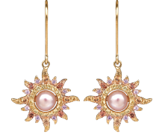
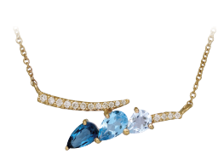
Diamonds
April Birthstones
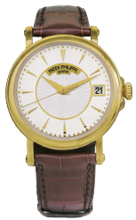
Pg 7
Pg 2

Pg 5
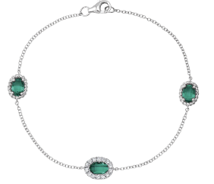
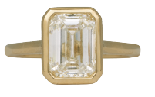

Pg 4
619.299.1500 www.leohamel.com
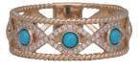  37921  New 14k gold braided band set with 0.17 carats of turquoise & 0.13 carats of earth-mined diamonds.  Retail Price: $2,175,  Our Price: $1,975 | 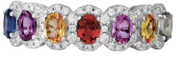  34730  New 18k white gold halo band set with 1.40 carats of multi-colored sapphires & 0.36 carats of earth-mined diamonds.  Retail Price: $3,095,  Our Price: $2,675 | 36576  New 14k gold Denny Wong Sunburst drop earrings set with peach freshwater pearls & 0.60 carats of multi-colored sapphires.  Retail Price: $2,375,  Our Price: $2,075
Mined Colored Gemstones
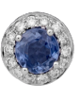  34771  New 18k gold halo earrings set with 0.58 carats of sapphires &  0.21 carats of earth-mined diamonds.  Retail Price: $1,595,  Our Price: $1,495 | 34107  New 14k gold Venetti bar pendant set with 0.79 carats of blue topaz & 0.08 carats of earth-mined diamonds.  Retail Price: $1,225,  Our Price: $1,095  LEGEND  k-karat = Purity of the gold  carat = Weight (not size) of the gemstone
Get Paid the Most for Your Valuables!
Selling to Leo’s professional buyers is easy, safe, and confidential. No appointment is necessary.
WE BUY!
Jewelry, Diamonds, Watches, Coins, Handbags and more!
San Diego  1851 San Diego Ave  619.299.1500 | La Mesa  8911 La Mesa Blvd  619.644.0000 | Solana Beach  921 Lomas Santa Fe  858.509.5900 | Oceanside  2530 Vista Way #H  760.757.2000

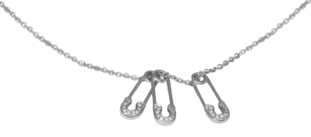  38189  New 14k gold Venetti safety pin pendant set with 0.09 carats of earth-mined diamonds on a 16” chain.  Retail Price: $875,  Our Price: $775 | 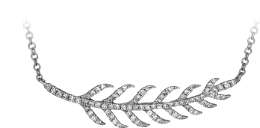  37926  New 14k gold leaf necklace set with 0.20 carats of earth-mined diamonds. Retail Price: $1,325, Our Price: $1,250 | 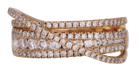  34823  New 18k gold crossover band set with  1.01 carats of earth-mined diamonds. Retail Price: $3,795, Our Price: $3,295
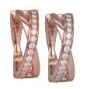  37752  Vintage 14k gold double-row hoop earrings set with 0.25 carats of earth-mined diamonds.  Retail Price: $1,925,  Our Price: $1,725 | 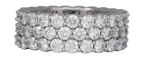  33241  Vintage 18k gold eternity band set with 3.63 carats of earth-mined diamonds.  Retail Price: $8,700,  Our Price: $7,500 | 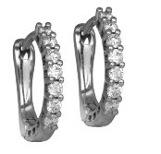  38197  New 14k gold Venetti huggie hoop earrings set with 0.32 carats of earth-mined diamonds.  Retail Price: $1,250, Our Price: $1,150
Diamonds
April Birthstones
38198  New 14k gold Venetti  heart earrings set with  0.28 carats of earth-mined diamonds.  Retail Price: $1,295,  Our Price: $1,175 | 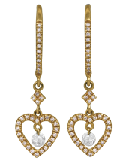  36475  Vintage 14k gold star  pendant set with  1.80 carats of earth-mined diamonds on an 18” chain.  Retail Price: $5,000,  Our Price: $4,000 | 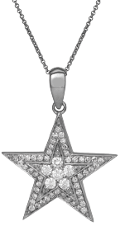

LEGEND
k-karat = Purity of the gold
carat = Weight (not size) of the gemstone

Engagement Rings &
Wedding Bands
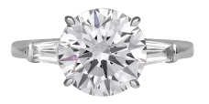  32832  New 14k gold engagement ring centered with a 3.54 carat lab-grown diamond flanked by 0.50 carats of lab-grown diamonds.  Retail Price: $8,250,  Our Price: $6,900 | 38446  New 14k gold solitaire engagement ring set with a  2.25 carat lab-grown diamond. Retail Price: $2,995,  Our Price: $2,595 | 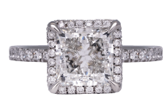  38389  New 14k gold halo engagement ring centered with a 3.09 carat lab-grown diamond & 0.38 carats of lab-grown diamonds.  Retail Price: $4,850, Our Price: $4,125
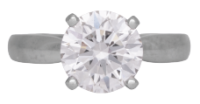  36758  Vintage platinum solitaire engagement set with a 2.21 carat lab-grown diamond.  Retail Price: $2,775,  Our Price: $2,375 | 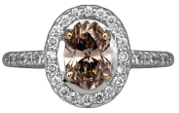  26570  Vintage 18k gold halo engagement ring centered with a 1.00 carat earth-mined champagne diamond & 0.32 carats of earth-mined diamonds.  Retail Price: $3,995,  Our Price: $3,195 | 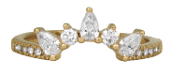  38227  New 14k gold curved band set with  0.55 carats of earth-mined diamonds.  Retail Price: $3,250,  Our Price: $2,895
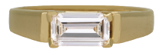  36894  Vintage 18k gold east-west solitaire engagement ring set with a 0.68 carat earth-mined diamond.  Retail Price: $3,650,  Our Price: $3,150 | 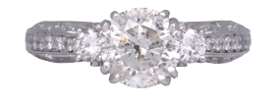  37583  Vintage 18k gold engagement ring set with a 1.56 carat earth-mined diamond center plus 0.50 carats of earth-mined diamonds.  Retail Price: $8,475,  Our Price: $6,600 | 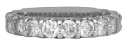  38311  New 14k gold band set with 2.00 carats  of earth-mined diamonds.  Retail Price: $4,425,  Our Price: $3,875

LEGEND
k-karat = Purity of the gold
carat = Weight (not size) of the gemstone

34873  New 14k gold Chatham halo bracelet set with 1.38 carats of lab-grown emeralds &  0.33 carats of lab-grown diamonds. *  Price: $2,150 | 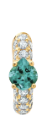  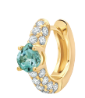  34869  New 14k gold Chatham huggie hoop earrings set with 0.92 carats of lab-grown chrysoberyl & 0.76 carats of lab-grown diamonds. *  Price: $2,460 | 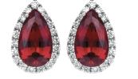  34555  New 14k gold Chatham halo earrings set with 3.91 carats of lab-grown rubies & 0.42 carats of lab-grown diamonds. *  Price: $3,270
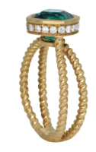  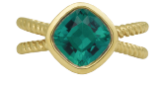  New 14k gold Chatham  under-halo ring centered with a  2.22 carat lab-grown emerald surrounded by 0.24 carats of  lab-grown diamonds. *  Price: $2,930 | 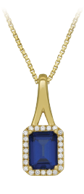  35122  New 14k gold Chatham  halo pendant set with a  2.20 carat  lab-grown sapphire &  0.16 carats of lab-grown  diamonds.  Price: $1,875  Shown on an 18” 14k gold box chain for $895; other lengths & styles available. | 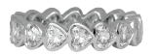  37130  New 14k gold eternity band set with  2.61 carats of lab-grown diamonds.  Retail Price: $3,495,  Our Price: $2,995
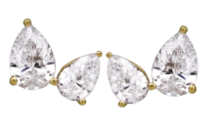  37291  Vintage 14k gold earrings set with 1.64 carats of lab-grown diamonds.  Retail Price: $1,325,  Our Price: $1,195 | 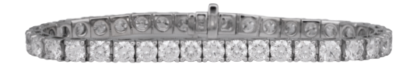  38391  New 14k gold tennis bracelet set with 11.98 carats of lab-grown diamonds.  Retail Price: $11,695,  Our Price: $10,250 | 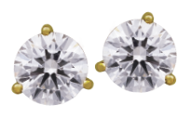  35663  New 14k gold earrings set with  4.02 carats of lab-grown diamonds.  Retail Price: $2,750,  Our Price: $2,250
Lab-Grown Diamond Jewelry
& Chatham Gemstones

The incredibly vibrant color of this gem is difficult to capture in a photograph.
You must see it in person to appreciate the stunning beauty of Chatham Gems.
I couldn’t be more impressed - Leo.

Vintage Designer Jewelry
& Handbags
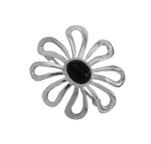  36279  Vintage sterling silver Tiffany & Co. Paloma Picasso Daisy Flower pin set with onyx.  Retail Price: $395,  Our Price: $275 | 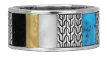  36790  Vintage sterling silver & 18k gold John Hardy Carved Chain ring set with turquoise, lapis, and mother-of-pearl.  Retail Price: $950, Our Price: $775 | 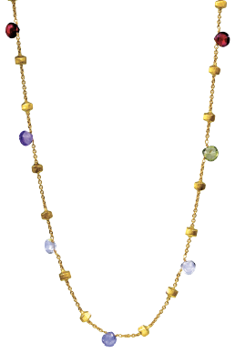  35676  Vintage 18k gold Marco Bicego Paradise necklace set with multi-colored gemstones on an 18" chain.  Retail Price: $3,550,  Our Price: $2,850
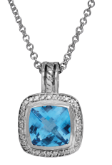  35754  Vintage sterling silver  David Yurman Albion pendant set with a 1.83 carat blue topaz & 0.17 carats of earth-mined diamonds.  Retail Price: $795,  Our Price: $595 | 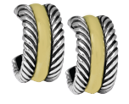  36492  Vintage sterling silver & 14k gold David Yurman Classic Cable huggie hoop earrings.  Retail Price: $750,  Our Price: $550 | 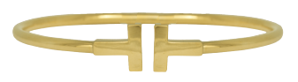  36716  Vintage 18k gold Tiffany & Co. T Wire flexible cuff bracelet.  Retail Price: $3,200,  Our Price: $2,440
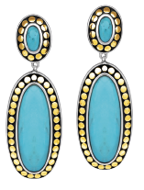  35711  Vintage sterling silver & 18k gold John Hardy Dot earrings set with turquoise.  Retail Price: $1,795,  Our Price: $1,495 | 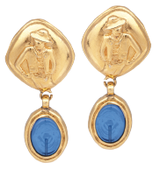  37485  Vintage gold tone Chanel clip-on dangle earrings set with blue Gripoix glass.  Retail Price: $900,  Our Price: $500 | 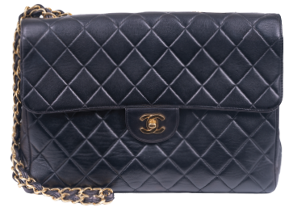  36949  Vintage black lambskin Chanel Classic Single Flap Jumbo handbag with card. Retail Price: $6,000, Our Price: $3,500

LEGEND
k-karat = Purity of the gold
carat = Weight (not size) of the gemstone

Pre-owned Watches
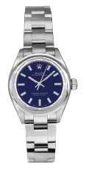  35707  Pre-owned Rolex Oyster  Perpetual watch with  a blue dial.  28mm. SS, A, C, F, O.  Retail Price: $7,500,  Our Price: $7,250 | 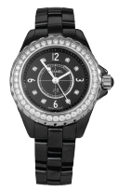  37608  Pre-owned Chanel  J12 watch with black  diamond dial & bezel.  29mm. C, Cr, D, F, Q.  Retail Price: $13,800,  Our Price: $6,200 | 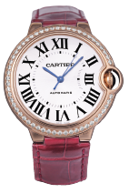  36601  Pre-owned Cartier  Ballon Bleu watch  with a diamond bezel. 36mm. 18KR, A, B, C, D, L, T.  Retail Price: $29,200,  Our Price: $15,995
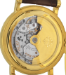  37524  Pre-owned Patek Philippe Calatrava Officer’s 5153 watch with exhibition case back. 38mm. 18K, A, B, C, E, F, L.  Retail Price: $33,000,  Our Price: $27,000 | 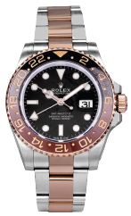  35708  Pre-owned Rolex  GMT Master-II watch  with root beer bezel. 40mm.  18KR & SS, A, B,  Price: $24,000 | 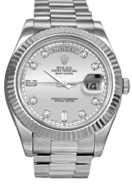  37492  Pre-owned Rolex Day-Date “President” watch with silver diamond dial & diamond bezel. 41mm. 18KW, A, B, C, D, F, Pr. Price: $43,995
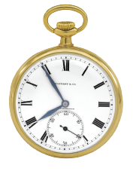  36599  Vintage Tiffany & Co. & Agassiz Watch Co. 21 Jewels pocket watch circa 1900s. 44mm. 18KY, M.  Retail Price: $8,500,  Our Price: $6,500 | 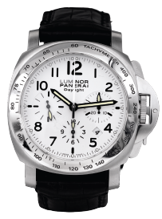  34980  Pre-owned Panerai Luminor Daylight Chrono PAM188 watch with a white dial. 44mm. SS, A, B, C, F, L.  Retail Price: $9,000, Our Price: $5,500 | LEGEND  18K – 18k yellow gold  24K – 24k yellow gold  18KR – 18k rose gold  A – automatic movement  B – box and/or papers  C – sapphire crystal  Cr – ceramic  D- diamonds  E – exhibition case  F – folding clasp  J – Jubilee bracelet  L – leather strap  M – mechanical movement  N – NATO strap  O – Oyster bracelet  Q – quartz movement  R – rubber strap  SS – stainless steel  T – tang buckle

Extraordinary Antique Jewelry

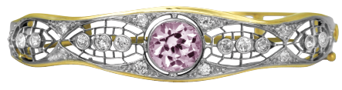  32160  Antique 14k gold bangle bracelet  set with a 3.96 carat kunzite &  1.00 carat of old European earth-mined diamonds.  Retail Price: $11,595,  Our Price: $9,695 | 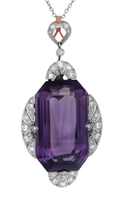  37695  Antique Edwardian platinum pendant set with a 40.00 carat amethyst &  1.00 carat of rose & single cut diamonds on a 16” chain.  Retail Price: $8,350,  Our Price: $6,995 | 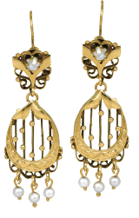  36718  Antique 14k gold filigree hook wire earrings set with seed pearls.  Retail Price: $2,975,  Our Price: $2,675

LEGEND
k-karat = Purity of the gold
carat = Weight (not size) of the gemstone

JOIN OUR EMAIL LIST AND GET MORE GREAT DEALS DELIVERED TO YOUR INBOX!
https://www.Leohamel.Com/join-email.

