CELEBRATE YOUR LIFE AT LEO’S
October Catalog 2026
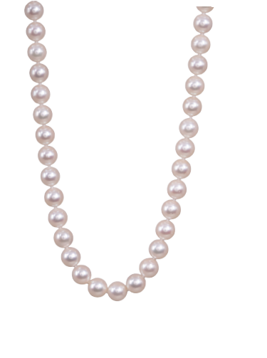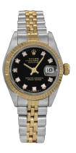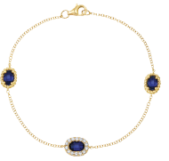

619.299.1500 www.leohamel.com

Chatham & Lab-Grown Jewelry
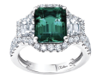  Catalog Number 5000314  New 18k gold Chatham ring set with a 4.10 carat lab-grown emerald plus 2.00 carats of lab-grown diamonds. *  Retail Price: $6,360,  Our Price: $5,595 | 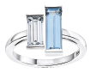  Catalog 000312  New 14k gold Chatham ring set with a 1.59 carat lab-grown spinel plus a  0.71 carat lab-grown diamond. *  Retail Price: $3,040,  Our Price: $2,750 | Catalog 34872  New 14k gold Chatham bracelet set with 2.07 carats of lab-grown sapphires plus 0.33 carats of  earth-mined diamonds. *  Price: $2,290
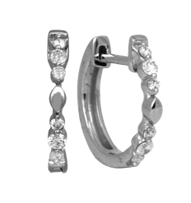  Catalog Number 5001708  New 14k gold huggie hoop earrings set with 0.16 carats of lab-grown diamonds.  Retail Price: $850, Our Price: $775 | 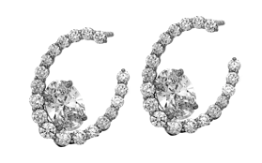  Catalog Number 5002672  New 14k gold hoop earrings set with 1.92 carats of lab-grown oval diamonds plus 0.28 carats of lab-grown diamonds.  Retail Price: $3,225,  Our Price: $2,995 | 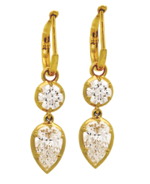  Catalog Number 5002675  New 14k gold earrings set with  2.02 carats of lab-grown pear diamonds plus 1.00 carat of lab-grown diamonds.  Retail Price: $3,495,  Our Price: $3,295

*The incredibly vibrant color of this gem is difficult to capture in a photograph. You must see it in person to appreciate the
stunning beauty of Chatham Gems. I couldn’t be more impressed - Leo.

Get Paid the Most for Your Valuables!
Selling to Leo’s professional buyers is easy, safe, and confidential.
No appointment is necessary.
WE BUY!
Jewelry, Diamonds, Watches, Coins, Handbags and more!
4 Locations
San Diego 619.299.1500, La Mesa 619.644.0000,
Oceanside 760.757.2000 and Solana Beach 858.509.5900

Engagement Rings & Wedding Bands
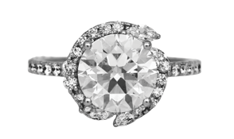  Catalog Number 5002173  New 14k gold halo engagement ring set with a 3.00 carat lab-grown diamond plus 0.83 carats  of lab-grown diamonds.  Retail Price: $4,075,  Our Price: $3,795 | 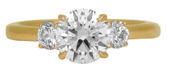  Catalog Number 5002223  New 14k gold engagement ring set with a 1.50 carat lab-grown diamond plus 0.36 carats of lab-grown diamonds.  Retail Price: $2,675,  Our Price: $2,495 | 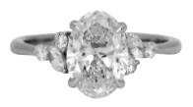  Catalog Number 5002174  New 14k gold engagement ring set with a 2.00 carat lab-grown oval diamond plus 0.44 carats of lab-grown diamonds.  Retail Price: $2,950,  Our Price: $2,750
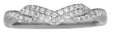  Catalog Number 5002224  New 14k gold band set with  0.20 carats of lab-grown diamonds.  Retail Price: $1,725,  Our Price: $1,595 | 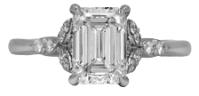  Catalog Number 5002218  New 14k gold under-halo engagement ring set with a 2.00 carat lab-grown emerald cut diamond plus 0.30 carats  of lab-grown diamonds.  Retail Price: $3,495, Our Price: $3,295 | 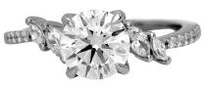  Catalog Number 5002133  New 14k gold engagement ring set with a 1.50 carat lab-grown diamond plus 0.23 carats of lab-grown diamonds.  Retail Price: $2,695,  Our Price: $2,350
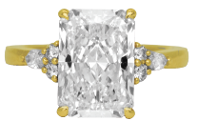  Catalog Number 5002200  New 14k gold engagement ring set with a 4.51 carat lab-grown radiant diamond plus 0.23 carats of lab-grown diamonds.  Retail Price: $5,695,  Our Price: $5,295 | 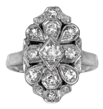  Catalog Number 5000151  Antique 14k gold ring set with 0.40 carats of single cut earth-mined diamonds.  Retail Price: $1,850,  Our Price: $1,595 | 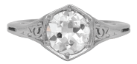  Catalog Number 41184  Antique platinum engagement ring set with a 1.10 carat old European cut earth-mined diamond.  Retail Price: $5,800,  Our Price: $4,850
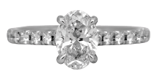  Catalog Number 5001737  Vintage 18k gold engagement ring set with a 1.52 carat oval earth-mined diamond plus 0.70 carats of earth-mined diamonds.  Retail Price: $12,275,  Our Price: $9,995 | 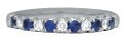  Catalog Number 5001328  New 14k gold band set with 0.47 carats of sapphires plus 0.34 carats of  earth-mined diamonds.  Retail Price: $2,475,  Our Price: $2,275

Hearts On Fire & New Jewelry
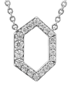  Catalog Number 5002347  New 18k gold Hearts On Fire Charmed Hex necklace set with  0.22 carats of earth-mined diamonds.  Retail Price: $1,910,  Our Price: $1,570 | 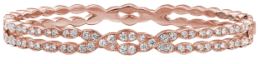  Catalog Number 5002349  New 18k rose gold Hearts On Fire Lorelei Floral bangle set with  1.45 carats of earth-mined diamonds.  Retail Price: $9,750,  Our Price: $7,995 | 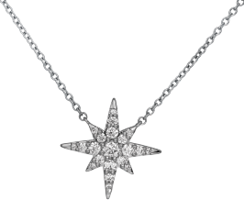  Catalog Number 5002354  New 18k gold Hearts On Fire Charmed Starburst necklace set with 0.31 carats of earth-mined diamonds.  Retail Price: $3,510,  Our Price: $2,900
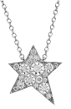  Catalog Number 5002396  New 18k gold Hearts On Fire Illa Cosmic necklace set with 0.17 carats of earth-mined diamonds.  Retail Price: $1,410,  Our Price: $1,185 | 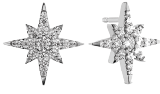  Catalog Number 5003243  New 18k gold Hearts On Fire Charmed Sunburst earrings set with 0.41 carats of earth-mined diamonds.  Retail Price: $4,030,  Our Price: $3,500 | 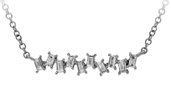  Catalog Number 5002759  New 14k gold pendant set with  0.21 carats of baguette earth-mined diamonds.  Retail Price: $1,750,  Our Price: $1,595
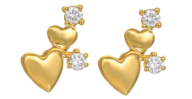  Catalog Number 5002642  New 14k gold heart earrings set with 0.05 carats of earth-mined diamonds.  Retail Price: $950, Our Price: $850 | 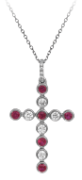  Catalog Number 5002594  New 14k gold cross necklace set with 0.37 carats of rubies plus 0.35 carats of earth-mined diamonds.  Retail Price: $3,125,  Our Price: $2,895 | 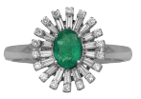  Catalog Number 5002651  New 14k gold halo ring set with a 0.93 carat oval emerald plus  0.53 carats of earth-mined diamonds.  Retail Price: $4,350,  Our Price: $3,995
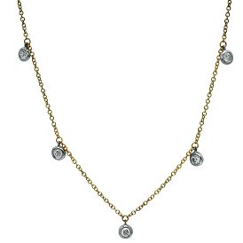

Catalog Number 5002711
New 14k gold station necklace set with 0.25 carats of earth-mined diamonds. Retail Price: $1,675,
Our Price: $1,495

Vintage Designer Jewelry & Handbags
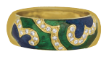  Catalog Number 5002063  Vintage 18k gold Hidalgo ring set with 0.36 carats of round brilliant earth-mined diamonds plus green  and blue enamel.  Retail Price: $4,500,  Our Price: $2,995 | Catalog Number 5003043  Vintage Tiffany & Co. Essential Pearls 7-7.75mm Akoya pearl  necklace with an 18k gold lobster clasp.  Retail Price: $3,700,  Our Price: $2,995 | 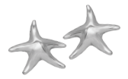  Catalog Number 40483  Vintage sterling silver Tiffany & Co. Elsa Peretti Starfish earrings.  Retail Price: $650, Our Price: $450
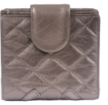  Catalog Number 39961  Vintage Chanel Cambon quilted leather folding wallet.  Retail Price: $900, Our Price: $675 |  | 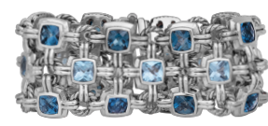  Catalog Number 55001880  Vintage sterling silver David Yurman bracelet set with cushion topaz.  Retail Price: $3,700,  Our Price: $2,300
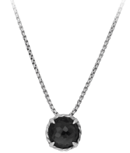  Catalog Number 5001863  Vintage sterling silver David Yurman Chatelâine Black Orchid necklace.  Retail Price: $375, Our Price: $285 | 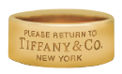  Catalog Number 5002830  Vintage 18k gold Tiffany & Co.  Return to Tiffany wide band.  Retail Price: $7, 000,  Our Price: $5,500 | 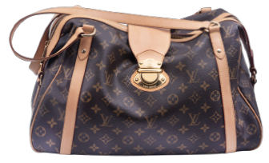  Catalog Number 5003055  Vintage Louis Vuitton Monogram Stresa canvas shoulder bag.  Retail Price: $2,200,  Our Price: $1,500

Antique & Vintage Jewelry
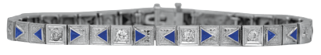  Catalog Number 5002609  Vintage 14k gold James Little Navajo cuff bracelet set with lapis, turquoise, and 1.50 carats of earth-mined diamonds.  Retail Price: $27,000,  Our Price: $21,500 | 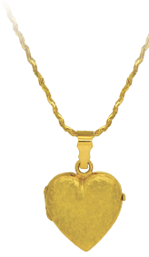  Catalog Number 5001824  Vintage 18k gold heart locket pendant.  Retail Price: $2,500,  Our Price: $2,150 | 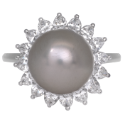  Catalog Number 5001735  Vintage platinum halo ring set with an 11.97mm white South Sea pearl plus  2.20 carats of pear earth-mined diamonds.  Pearls are very difficult to photograph.  This pearl looks better in real life than in  the picture. Come see it if you’re  interested.  Retail Price: $4,700, Our Price: $3,995
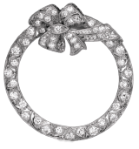  Catalog Number 5001841  Antique platinum bow & circle brooch/pendant set with  1.31 carats of old European cut earth-mined diamonds.  Retail Price: $5,100,  Our Price: $4,550 | 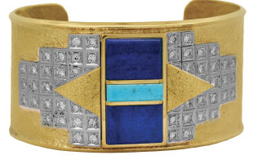  Catalog Number 5001738  Antique 14k gold bracelet set with 0.40 carats of old European cut earth-mined diamonds plus lab-grown sapphires.  Retail Price: $3,895,  Our Price: $3,395 | 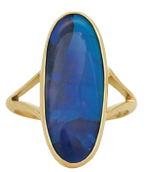  Catalog Number 38895  Vintage 14k gold ring set with a 6.12 carat oval black opal.  Retail Price: $5,725, Our Price: $4,895
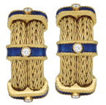

Catalog Number 5001988
Vintage 18k gold blue enamel half hoop earrings set with
0.25 carats of earth-mined diamonds.
Retail Price: $8000,
Our Price: $6,550

New & Pre-owned Watches
LEGEND  18KW – 18k white gold  18KY – 18k yellow gold  A – automatic movement  B – box and/or papers  C – sapphire crystal  D – diamonds  F – folding clasp  J – Jubilee bracelet  L – leather strap  O – Oyster bracelet  MOP – mother-of-pearl  Q – quartz movement  SS – stainless steel  T – tang buckle | 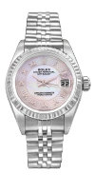  Catalog Number 5000371  Pre-owned Rolex Datejust watch with a mother-of-pearl dial. 26mm. SS, A, B, C, F, J, MOP.  Retail Price: $10,500,  Our Price: $7,995 | Catalog Number 5002326  Pre-owned Rolex Datejust watch with a black diamond dial. 26mm. 18KY & SS, A, C, D, F, J.  Retail Price: $15,100,  Our Price: $7,600
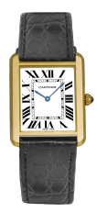  Catalog Number 5002131  Pre-owned Cartier Tank Solo watch with a cream dial. 27mm. 18KY & SS, C, L, Q, T.  Retail Price: $7,500,  Our Price: $5,850 | 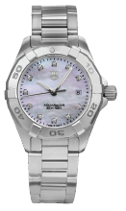  Catalog Number 5002500  Pre-owned TAG Heuer Aquaracer watch with a mother-of-pearl diamond dial. 27mm. SS, C, D, F, MOP, Q.  Retail Price: $2,250,  Our Price: $1,450 | 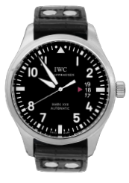  Catalog Number 55002673  Pre-owned IWC Mark XVII watch with a black dial. 40mm. SS, A, B, C, L, T.  Retail Price: $5,800,  Our Price: $4,300
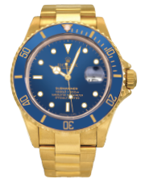  Catalog Number 5000986  Pre-owned Rolex Submariner watch with a blue dial. 40mm. 18KY, A, C, F, O.  Retail Price: $50,900,  Our Price: $32,995 | 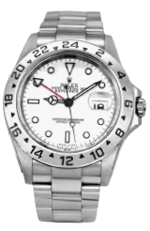  Catalog Number 5001567  Pre-owned Rolex Explorer II watch with a white dial. 40mm. SS, A, C, F, O.  Retail Price: $10,600,  Our Price: $10,250 | 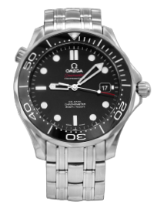  Catalog Number 5002508  Pre-owned Omega Seamaster watch with a black dial. 41mm. SS, A, C, F.  Retail Price: $6,700,  Our Price: $4,795

Judy Mayfield Collection
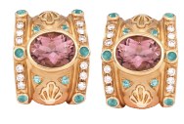  Catalog Number 31519  New 18k gold Judy Mayfield shell earrings set with 3.59 carats of oval salmon tourmalines, 0.53 carats of Paraiba tourmalines, and 0.45 carats of earth-mined diamonds.  Retail Price: $13,530,  Our Price: $10,500 | 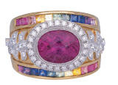  Catalog Number 17064  New 18k gold Judy Mayfield ring set with a 2.63 carat oval rubellite tourmaline, 1.49 carats of rainbow sapphires, and 0.38 carats of earth-mined diamonds.  Price: $10,115 | 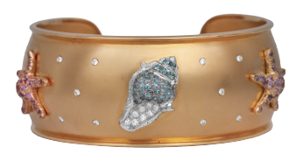  Catalog Number 17133  New 18k gold Judy Mayfield seashell cuff bracelet set with 3.04 carats of pink and purple sapphires, 0.53 carats of Paraiba tourmalines, and 0.44 carats of earth-mined diamonds.  Retail Price: $39,125,  Our Price: $29,995

