CELEBRATE YOUR CHRISTMAS AT LEO’S
November 1 Catalog 2026
Leo’s Christmas Wish Book
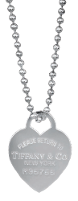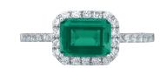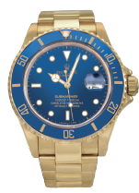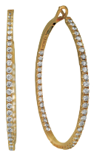
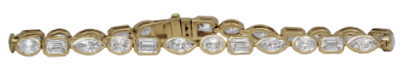

619.299.1500 www.leohamel.com

Chatham & Lab-Grown Jewelry
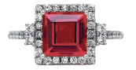  Catalog Number 34128  New 14k gold Chatham ring set with a 3.45 carat lab-grown ruby plus 0.53 carats of lab-grown diamonds in the halo & band.*  Price: $3,770 | Catalog Number 35137  New 14k gold Chatham ring set with a  1.20 carat lab-grown emerald plus 0.38 carats of lab-grown diamonds in the halo & band.*  Price: $2,430 | 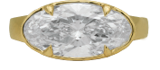  Catalog 5001866  New 14k gold solitaire engagement ring set with a 4.25 carat lab-grown diamond.  Retail Price: $6,250,  Our Price: $5,795
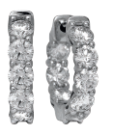  Catalog Number 5000593  New 14k gold inside out huggie hoop earrings set with 2.05 carats of  lab-grown diamonds.  Retail Price: $2,250,  Our Price: $2,095 | 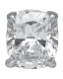  Catalog Number 5001700  New 14k gold earrings set with  1.42 carats of lab-grown diamonds.  Retail Price: $1,575,  Our Price: $1,400 | Catalog Number 40450  New 14k gold tennis bracelet set with 7.85 carats of lab-grown diamonds.  Price: $8,325

*The incredibly vibrant color of this gem is difficult to capture in a photograph. You must see it in person to appreciate the
stunning beauty of Chatham Gems. I couldn’t be more impressed - Leo.

Get Paid the Most for Your Valuables!
Selling to Leo’s professional buyers is easy, safe, and confidential.
No appointment is necessary.
WE BUY!
Jewelry, Diamonds, Watches, Coins, Handbags and more!
4 Locations
San Diego 619.299.1500, La Mesa 619.644.0000,
Oceanside 760.757.2000 and Solana Beach 858.509.5900

Gifts Under $500
Catalog Number 5002752  Vintage sterling silver Tiffany & Co. Please Return to Tiffany heart tag pendant on a 35" necklace.  Retail Price: $750, Our Price: $500 | 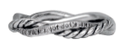  Catalog Number 41209  Vintage sterling silver David Yurman  Petite Infinity band set with 0.07 carats of earth-mined diamonds.  Retail Price: $495, Our Price: $395 | 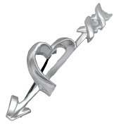  Catalog Number 5003163  Vintage sterling silver Tiffany & Co. Paloma Picasso Graffiti brooch.  Retail Price: $450, Our Price: $295
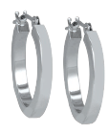  Catalog Number 5002418  Vintage 14k white gold hoop earrings.  Retail Price: $295, Our Price: $250 | 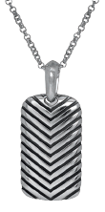  Catalog Number 5003654  Vintage sterling silver David Yurman  Chevron Tag pendant.  Retail Price: $325, Our Price: $225 | 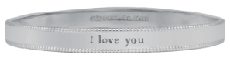  Catalog Number 5003341  Vintage sterling silver Tiffany & Co. I Love You bangle.  Retail Price: $700, Our Price: $475
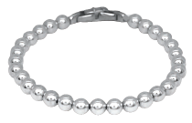  Catalog Number 5003642  Vintage sterling silver David Yurman Spiritual Beads bracelet.  Retail Price: $450, Our Price: $325 | 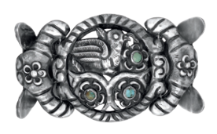  Catalog Number 5003084  Vintage sterling silver turquoise bird and flower bracelet.  Retail Price: $550, Our Price: $415 | 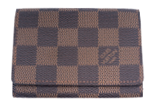  Catalog Number 40282  Vintage Louis Vuitton Damier Ebene card wallet.  Retail Price: $550, Our Price: $400

Gifts Under $1500
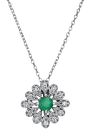  Catalog Number 5002601  New 14k gold flower necklace set with a 0.30 carat emerald plus  0.07 carats of earth-mined diamonds in the halo.  Retail Price: $1,095,  Our Price: $995 | 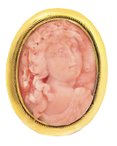  Catalog Number 5003397  Antique 14k gold pink coral cameo brooch.  Retail Price: $1,600,  Our Price: $,1,295 | 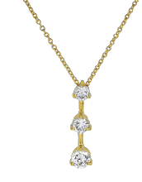  Catalog Number 5003059  Vintage 14k gold necklace set with 0.75 carats of earth-mined diamonds.  Retail Price: $1,725,  Our Price: $1,475
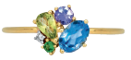  Catalog Number 5003321  New 14k gold ring set with  .09 carats of blue zircons, peridots, tanzanites, and tsavorites plus  0.03 carats of earth-mined diamonds.  Retail Price: $1,495,  Our Price: $1,350 | 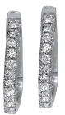  Catalog Number 5003035  New 14k gold huggie hoop earrings set with 0.12 carats of earth-mined diamonds.  Retail Price: $1,375,  Our Price: $1,250 | 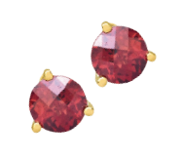  Catalog Number 5003956  New 14k gold earrings set with  2.16 carats of garnets.  Retail Price: $1,250,  Our Price: $1,095
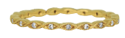  Catalog Number 5003928  Vintage 18k gold Beverley K eternity band set with 0.08 carats of earth-mined diamonds.  Retail Price: $750,  Our Price: $625 | 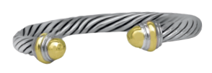  Catalog Number 5003324  Vintage sterling silver and 14k gold  David Yurman Classic Cable bracelet.  Retail Price: $1,050,  Our Price: $795 | 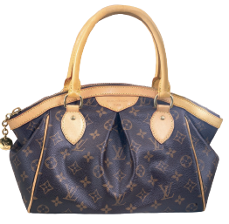  Catalog Number 5003706  Vintage Louis Vuitton Tivoli PM handbag.  Retail Price: $1,800,  Our Price: $1,250

Gifts Under $2500
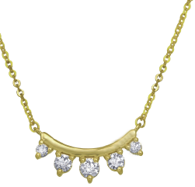  Catalog Number 5002951  New 14k gold spike necklace set with 0.30 carats of earth-mined diamonds.  Retail Price: $2,475,  Our Price: $2,250 | 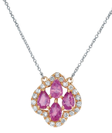  Catalog Number 5001923  Vintage 14k gold necklace set with 1.80 carats of pink sapphires plus a 0.44 carats earth-mined diamonds halo.  Retail Price: $2,900,  Our Price: $2,395 | 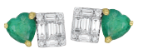  Catalog Number 5002614  New 14k gold Toi Et Moi earrings set with  0.45 carats of emeralds plus 0.24 carats of  earth-mined diamonds.  Retail Price: $1,750,  Our Price: $1,595
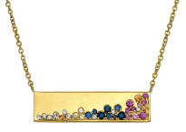  Catalog Number 5001841  New 14k gold bar pendant set with 0.44 carats of multicolor sapphires plus 0.04 carats of earth-mined diamonds on an 18" cable chain.  Retail Price: $1,775,  Our Price: $1,625 | 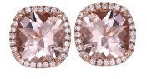  Catalog Number 5001915  Vintage 14k gold earrings set with 2.60 carats of morganites plus 0.16 carats of earth-mined diamonds in the haloes.  Retail Price: $2,675,  Our Price: $2,375 | 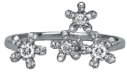  Catalog Number 5002636  New 14k gold flower ring set with  0.25 carats of earth-mined diamonds.  Retail Price: $2,075,  Our Price: $1,950
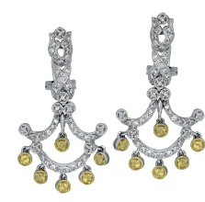  Catalog Number 5003625  Vintage 14k gold chandelier earrings set with 0.40 carats of earth-mined diamonds plus 0.28 carats of yellow earth-mined diamonds.  Retail Price: $2,725,  Our Price: $2,375 | 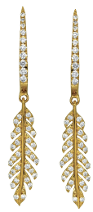  Catalog Number 5002971  New 14k gold feather earrings set with 0.35 carats of earth-mined diamonds.  Retail Price: $2,075,  Our Price: $1,875

Gifts Over $2500
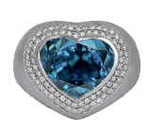  Catalog Number 5003242  New 18k gold ring set with a  9.20 carat blue zircon plus a halo of 0.50 carats of earth-mined diamonds.  Retail Price: $18,075,  Our Price: $15,995 | 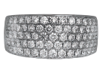  Catalog Number 5002310  Vintage 14k gold band set with 1.95 carats of earth-mined diamonds.  Retail Price: $5,250,  Our Price: $4,350 | 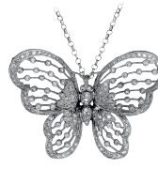  Catalog Number 5002870  Vintage 18k gold butterfly necklace set with  0.54 carats of earth-mined diamonds.  Retail Price: $5,500, Our Price: $4,500
Catalog Number 5002427  Vintage 14k gold hoop earrings set with 1.88 carats of earth-mined diamonds.  Retail Price: $4,295,  Our Price: $3,825 | 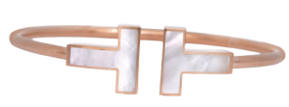  Catalog Number 5003511  Vintage 18k gold Tiffany & Co.  T Wire mother-of-pearl bangle with box.  Retail Price: $4,250,  Our Price: $3,450 | 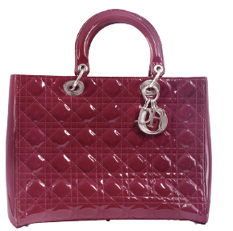  Catalog Number 5003422  Vintage Dior Lady Dior burgundy leather  tote with shoulder strap.  Retail Price: $7,700, Our Price: $4,995
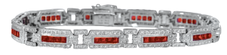

Catalog Number 5001727
Vintage 18k gold bracelet set with 5.50 carats of rubies plus 2.20 carats of earth-mined diamonds.
Retail Price: $15,500,
Our Price: $11,995

New & Pre-owned Watches
LEGEND  18KY – 18k yellow gold  A – automatic movement  B – box and/or papers  C – sapphire crystal  E – exhibition back  F – folding clasp  L – leather strap  O – Oyster bracelet  MOP – mother-of-pearl  Q – quartz movement  SS – stainless steel  T – tang buckle | 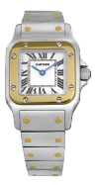  Catalog Number 5003374  Pre-owned Cartier Santos watch with a white dial. 24mm. 18KY & SS, C, F, Q.  Retail Price: $8,500,  Our Price: $5,395 | 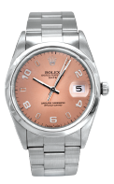  Catalog Number 55003192  Pre-owned Rolex Datejust watch with a rose dial. 34mm. SS, A, C, F, O.  Retail Price: $8,150,  Our Price: $6,750
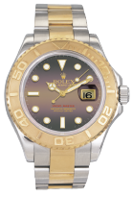  Catalog Number 5003551  Pre-owned Rolex Yacht-Master watch with a black mother-of-pearl dial. 40mm. 18KY & SS, A, B, C, F, O, MOP..  Retail Price: $19,750,  Our Price: $16,495 | Catalog Number 5000986  Pre-owned Rolex Submariner watch with a blue dial. 40mm. 18KY, A, C, F, O.  Retail Price: $50,900,  Our Price: $32,995 | 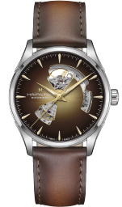  Catalog Number 5003744  New Hamilton Jazzmaster Open Heart watch with an exhibition case back. 42mm. SS, A, B, C, E, F, L.  Retail Price: $1,245
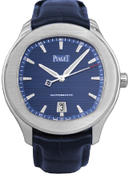  Catalog Number 5003123  Pre-owned Piaget Polo S watch with an exhibition case back. 42mm. SS, A, B, C, E, L, T.  Retail Price: $14,000,  Our Price: $9,750 | 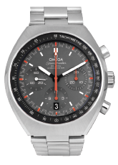  Catalog Number 5003127  Pre-owned Omega Speedmaster Mark II watch with a grey dial. 42.5mm. SS, A, B, C, F.  Retail Price: $8,000,  Our Price: $6,795 | 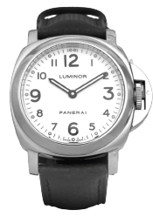  Catalog Number 5001698  Pre-owned Panerai Luminor watch with a white dial. 44mm. SS, A, B,  C, F.  Retail Price: $5,900,  Our Price: $4,350

Black Friday Sale

Shop over $2 million in jewelry, watches and accessories at up
to 50% OFF or more!
Shop select Hearts On Fire diamond jewelry
at up to 50% OFF!
Shop ALL vintage
Tiffany & Co. jewelry at 50% OFF!

Friday November 27th
11:00-6:00PM
Saturday November 28th
11:00-5:00PM

